**REST API FOR EXPENSE TRACKER APP**

**Environment Setup:**

1.Move to the virtual environment using with expense tracker app is created and activate it.

In windows run activate.bat to activate the environment.

2.Install django rest framework library.

**pip install djangorestframework==3.2.3**

3. Add rest framework to the installed apps in settings.py of the project:

**INSTALLED_APPS = (  
# ...  
'rest_framework',  
)**

4. Add the below code to settings.py file.

**REST_FRAMEWORK = {  
'DEFAULT_PERMISSION_CLASSES': [  
'rest_framework.permissions.DjangoModelPermissionsOrAnonReadOnly'  
]  
}**

**Build Process:**

1.Create a api folder inside app directory and inside it create the two files __init__.py and serializers.py.

**api/  
 __init__.py  
 serializers.py**

2.Create serializers.py file and write serialization code.

3.Create views.py file and handle the view logic.

4.Create urls.py in api folder ,add the urls to respective views.

5.Add the urls to urls.py in main project.

Outputs/Screenshots:

1.Enter the url : <http://127.0.0.1:8000/api/expense/>

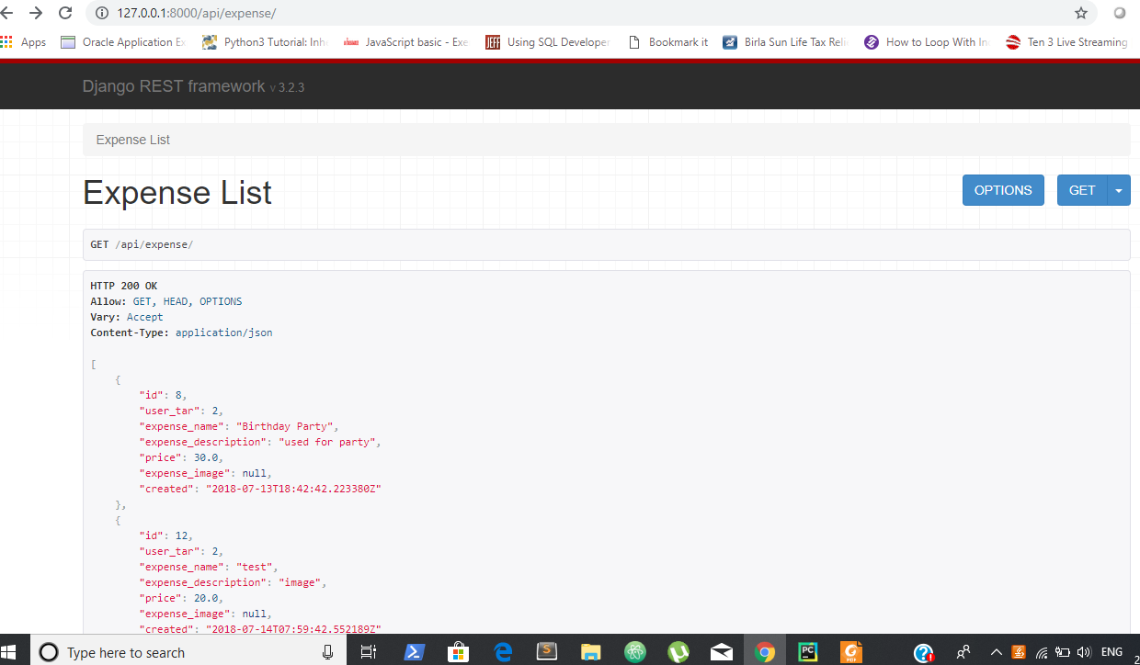

2.Enter the url: <http://127.0.0.1:8000/api/expense/8/>

